Some failure mode in training GAN:

Mode collapse:

The causes for mode collapse can vary, from an ill-suited objective function to the impact of the chosen GAN architecture having in consideration the data under analysis.

A mode collapse can also be identified by reviewing the line plot of model loss. The line plot will show oscillations in the loss over time, most notably in the generator model, as the generator model is updated and jumps from generating one mode to another model that has different loss.

We can impair our stable GAN to suffer mode collapse a number of ways. Perhaps the most reliable is to restrict the size of the latent dimension directly, forcing the model to only generate a small subset of plausible outputs.
Specifically, the ‘latent_dim‘ variable can be changed from 100 to 1, and the experiment re-run.
In this case, the loss for the discriminator sits in a sensible range, although the loss for the generator jumps up and down. The accuracy for the discriminator also shows higher values, many around 100%, meaning that for many batches, it has perfect skill at identifying real or fake examples, a bad sign for image quality or diversity.

The figure with learning curve and accuracy line plots is created and saved.
In the top subplot, we can see the loss for the generator (green) oscillating from sensible to high values over time, with a period of about 25 model updates (batches). We can also see some small oscillations in the loss for the discriminator on real and fake samples (orange and blue).
In the bottom subplot, we can see that the discriminator’s classification accuracy for identifying fake images remains high throughout the run. This suggests that the generator is poor at generating examples in some consistent way that makes it easy for the discriminator to identify the fake images.
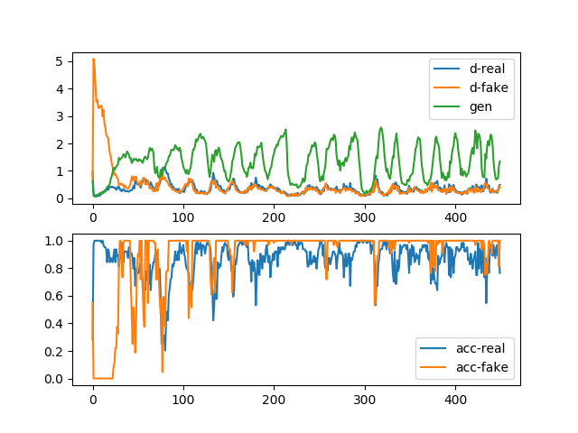

In summary, you can identify a mode collapse as follows:
- The loss for the generator, and probably the discriminator, is expected to oscillate over time.
- The generator model is expected to generate identical output images from different points in the latent space.

We can impair our stable GAN to suffer mode collapse a number of ways. Perhaps the most reliable is to restrict the size of the latent dimension directly, forcing the model to only generate a small subset of plausible outputs.
Specifically, the ‘latent_dim‘ variable can be changed from 100 to 1, and the experiment re-run

Non-convergence and instability:
The Generator (G) loss can lead to the GAN instability, which can be the cause of the gradient vanishing problem when the Discriminator (D) can easily distinguish between real and fake samples.

The likely way that you will identify this type of failure is that the loss for the discriminator has gone to zero or close to zero. In some cases, the loss of the generator may also rise and continue to rise over the same period.

This type of loss is most commonly caused by the generator outputting garbage images that the discriminator can easily identify.

There are many ways to impair our stable GAN to achieve a convergence failure, such as changing one or both models to have insufficient capacity, changing the Adam optimization algorithm to be too aggressive, and using very large or very small kernel sizes in the models.

Line plots of learning curves and classification accuracy are created.
The top subplot shows the loss for the discriminator (blue) and generator (orange) and clearly shows the drop of both values down towards zero over the first 20 to 30 iterations, where it remains for the rest of the run.
The bottom subplot shows the discriminator classification accuracy sitting on 100% for the same period, meaning the model is perfect at identifying real and fake images. The expectation is that there is something about fake images that makes them very easy for the discriminator to identify.

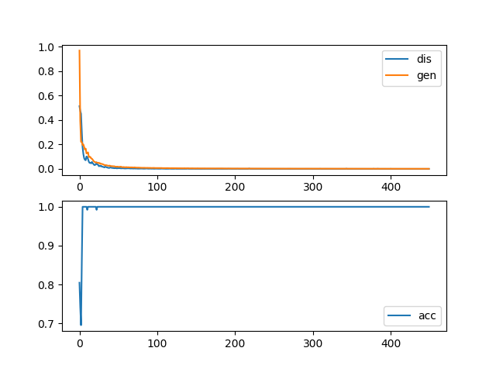

Finally, reviewing samples of generated images makes it clear why the discriminator is so successful. Samples of images generated at each epoch are all very low quality, showing static, perhaps with a faint figure eight in the background.

It is useful to see another example of this type of failure.
In this case, the configuration of the Adam optimization algorithm can be modified to use the defaults, which in turn makes the updates to the models aggressive and causes a failure for the training process to find a point of equilibrium between training the two models.
For example, the discriminator can be compiled as follows:
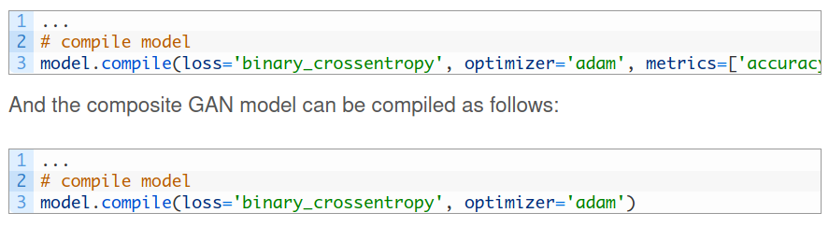
Plot:

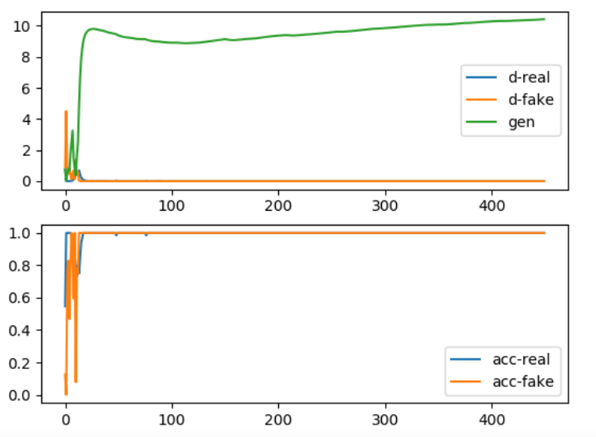

We can review the properties of a convergence failure as follows:
- The loss for the discriminator is expected to rapidly decrease to a value close to zero where it remains during training.
- The loss for the generator is expected to either decrease to zero or continually decrease during training.
- The generator is expected to produce extremely low-quality images that are easily identified as fake by the discriminator.

